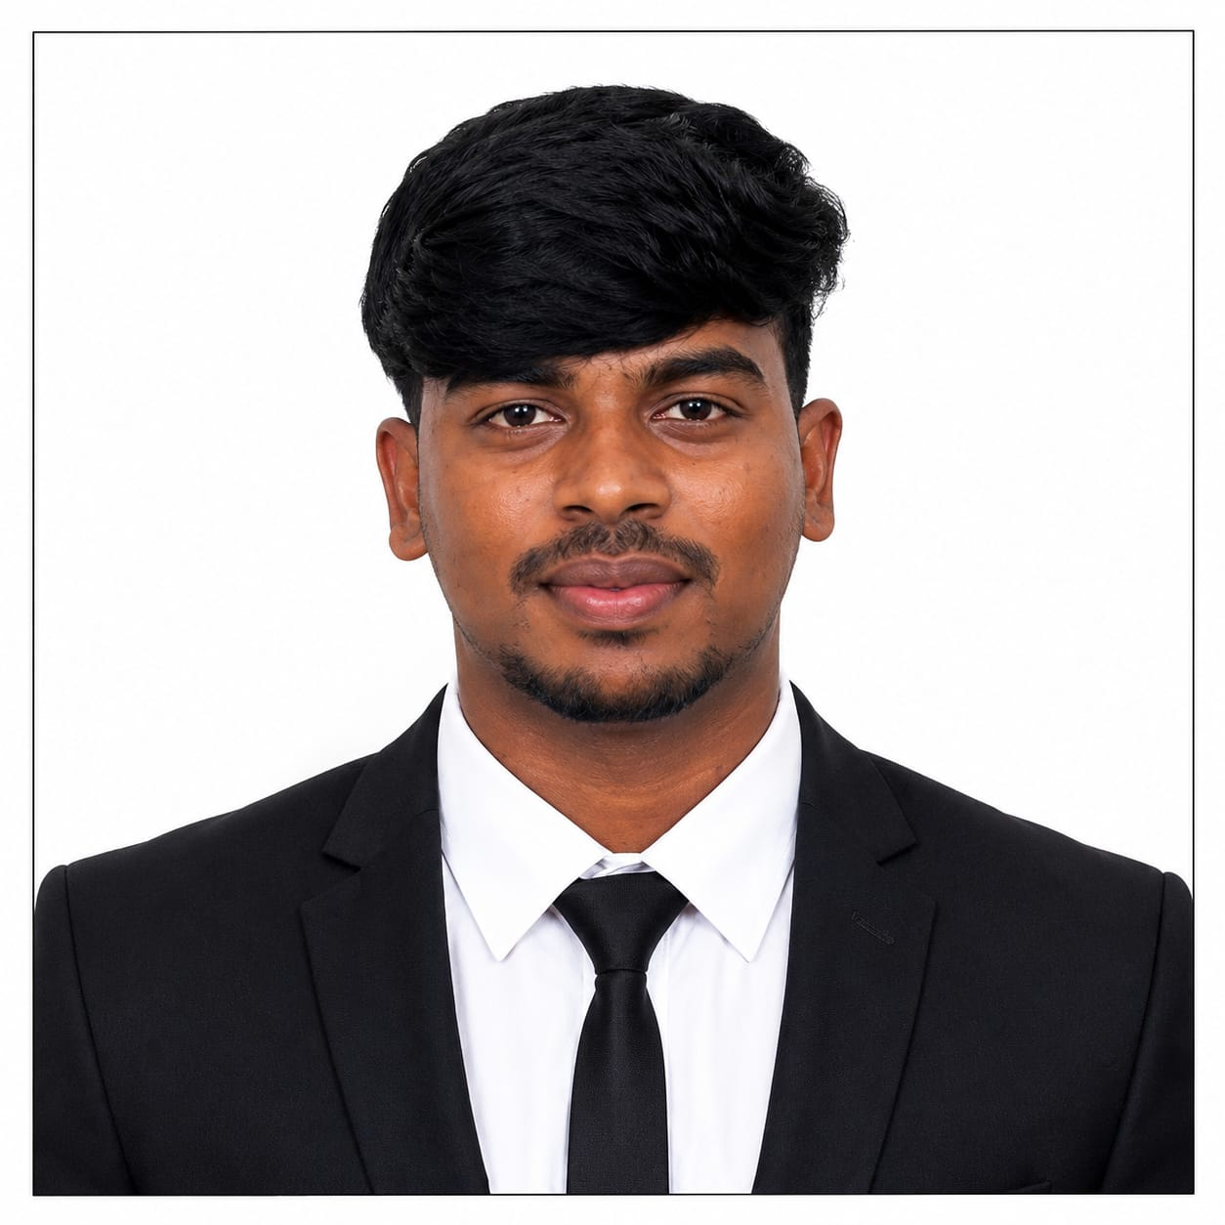
RESUME

GOWTHAM M
7/118, BOYAR STREET,
DEVANANKURICHI ,
DEVANANKURICHI (PO),
TIRUCHENGODE (TK),
NAMAKKAL (DT) – 637209.
mrgowthammrgowtham1@gmail.com
Mobile no: 6385435140

OBJECTIVE:
To work in an environment which encourages me to succeed and grow professionally where I can utilize my skills and knowledge appropriately.
ACADEMIC PROFILE:
Academic | School & College | Board & University | Percentage | Year of passing
DIPLAMO | K.S.R Institute of  Technology,  Tiruchengode. | Dote  (Chennai) | 91.5%  (upto IVth sem) | 2027
SSLC | MDV higher  secondary  school , Tiruchengode | State Board  (Tamil Nadu) | 45% | 2022

PERSONALITY TRAITS:
- I am a confident and hardworking person.
- Strong motivational and leadership skills.
- I am friendly, responsible and always willing to learn new things.
- Ability to work individually as well as in a group.
PROFESSIONALSKILLS:
- AutoCAD
- Basic computer software & computer hardware.

CO-CURICULAR ACTIVITIES
- Participated in paper presentation AT KSRInstitute of technology
- Participated in paper presentation AT SAKTHI polytechnic college
- Participated in paper presentation AT SHREE Venkateshwara
- Participated in paper presentation AT KSR ards and science

PROJECT:
- I’m currently doing my diploma project on “EASY CAR PARKING SYSTEM BY 90-DEGREE STEERING MECHANISM”.

AREA OF INTERST:
- Manufacturing line
- catia
- Design
- Car design
- AutoCAD

EXTRA-CURRICULARACTIVITIES:
- Kabaddi
- Running
- Volleyball

PERSONAL PROFILE:
Name : GOWTHAM M
Father’s Name : MADHURAIVEERAN
Date of Birth : 31/05/2006
Nationality : Indian
Languages Known : Tamil &English &Telugu (Read, Write)

DECLARATION:
I hereby declare that all the details given above are true and correct to the best of my Knowledge and Belief.

Date :
Place : SIGNATURE
(GOWTHAM.M)

